

# School of InfoComm Technology

**Deep Learning Assignment**

Diploma in DS / IT

Oct 2023 Semester

**ASSIGNMENT 1**

(30% of DL Module)

**Submission Deadline:**

**Presentation: 9th Dec 2023 11:59PM**

**Report and Code: 9th Dec 2023 11:59PM**

|  |  |  |
| --- | --- | --- |
| **Tutorial Group** | **:** | **T01 / T02** |
| **Student Name** | **:** |  |
| **Student Number** | **:** |  |

**Penalty for late submission:**

10% of the marks will be deducted every calendar day after the deadline.

**NO** submission will be accepted after 17th Dec 2023, 11:59PM.

# Assignment Specifications

## Objective

Build an image classification model to recognize and classify 10 different types of food.

## Dataset

Download the images dataset (5GB) from Kaggle (<https://www.kaggle.com/kmader/food41>). You may need to register an account with Kaggle if you have not already done so.

This dataset contains images of food, organized by the type of food (a total of 101 types). There are 1000 images for each type of food, so in total we have 101,000 images.

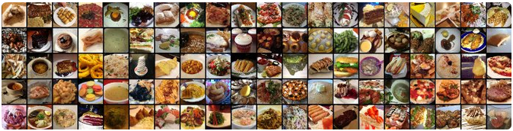

For this assignment, we randomly assign 10 different types of food for each student to perform image classification task. **Please refer to the Appendix at the end of this document for the food list file (a .txt file) assigned to you.**

A Jupyter notebook **Image_Preprocessing.ipynb** is also provided for you to extract the 10 types of food assigned to you. Download the complete set of .txt files (Food_list.zip) from BrightSpace and enter the .txt file assigned to you in **Image_Preprocessing.ipynb** to extract the images assigned to you.

**Image_Preprocessing.ipynb** also helps you to split the images into:

* Training (750 images per food)
* Validation (200 images per food)
* Testing samples (50 images per food)

Feel free to adjust the train, validation and test ratios if required. You only need to run this file once to generate the train, validation and test folders with the corresponding images. **Do remember to run this file first before proceeding to the suggested tasks.**

## Suggested Tasks

You should make use of the **Assignment_1_[your_name].ipynb** Jupyter Notebook file to implement your model. It is recommended to tackle this problem by using the suggested structure below.

**Step 1 – Load Data**

* Load the Train, Validation and Test images into Jupyter Notebook
* Resize all the images to 150 x 150 (recommended)
  + If it takes too long for your computer to run, you can downsize the images to 100 x100 or 50 x 50.

**Step 2 – Develop the Image Classification Models**

* You are required to develop at least **TWO** different models:
  + One Model trained from scratch using conv2D & dense layers
  + One Model utilizing pre-trained models
* For each model, you are suggested to follow the universal machine learning workflow to develop the model and improve the model performance, i.e.
  + Start with a baseline model
  + Scale up the model until overfitting occurs
  + Regularize the model accordingly
* Analyze the model performance and tune the model’s hyperparameters during training phase
  + **Remember** **to record model performance curves** for report writing

**Step 3 – Evaluate the models using the Test Images**

* Evaluate the developed models using Test Images
* Compare the model performance during testing phase
* Recommend the best model

**Step 4 – Use the Best Model to make prediction**

* Based on your assigned food types, download at least **THREE** food images from internet
* Feed the images into your Best Model and see whether the model can classify the food images correctly

## Report Format & Content Guidelines

Write an **INDIVIDUAL** report with the following sections (see Table below).

Suggested content description and word count are provided for each section. You are free to include other relevant information you deem necessary in the sections.

*(Note: For a page with 1-inch margins, 12-point Arial font, and minimal spacing elements, a good rule of thumb is* ***500 words*** *for a single-spaced page)*

|  |  |  |
| --- | --- | --- |
|  | **Suggested Report Sections & Content Guidelines** | **Word Count** |
| 1. | Table of Contents | NA |
| 2. | Overview   * Describe the problem, the objective and the approach. | Min: 300 words  Max: 1000 words |
| 3. | Data Preprocessing and Data Loading   * Describe how you preprocess the data and load data into Jupyter Notebook | Min: 200 words  Max: 500 words |
| 4. | Develop the Image Classification Models (at least **TWO**)   * Describe how you build & train the models, tuning model hyperparameters * Analyze the model performance during training phase | Min: 1000 words  Max: 2000 words |
| 5. | Evaluate models using Test images   * Compare the models’ performance during testing phase * Recommend the best model and explain why | Min: 300 words  Max: 1000 words |
| 6. | Use the Best Model to perform classification   * Explain how to apply the model on real life images * Explain and analyze the model prediction | Min: 200 words  Max: 500 words |
| 7. | Summary   * Summarize your model performance and provide suggestions for further improvements | Min: 100 words  Max: 500 words |

# Presentation and Demonstration

You are required to submit a **video recorded presentation** to showcase and demo your work using your power-point and/or jupyter notebook.

During the recording, your webcam must be turn on, clearly showing your face, for authentication.

The video recorded presentation should **not exceed 10 minutes**.

Video recorded presentations which exceed the allotted time will be penalized.

This video assignment app, powered by Bongo, allows students to capture their presentations multiple times and finally choose their best presentation to be submitted. Each student is to practice the presentation in advance to ensure completion **within 10 minutes**. The recording must include both webcam (clearly showing the student's face for authentication) and slides or codes (whichever is applicable).

Select the **RECORD VIDEO** option and choose **CAMERA + SCREEN** as shown in the figure below. The figure may differ with the constantly update of the Bongo software, hence students may see a different layout but general steps should still apply.

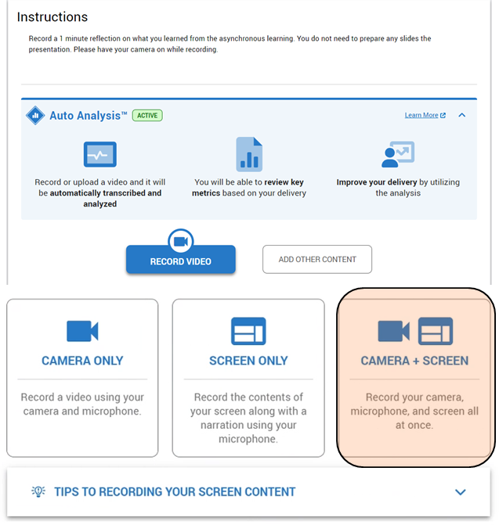

After recording the video, click save (as shown below) and it will be ready for students to append it for submission.



Select the video by clicking on the Star and click **SUBMIT**.

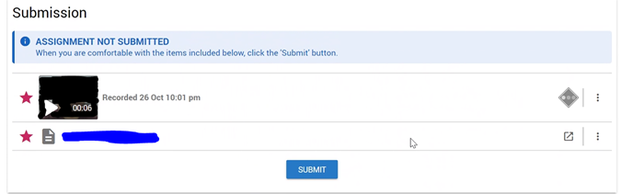

# Deliverables

For this assignment, you must submit all the following items into POLITEMall by **9th Dec 2023, 11:59pm**:

1. A deck of **“Assignment 1 Presentation_[student_name].pptx”** presentation slide

This is the deck of final presentation slides which you used to conduct your recorded presentation

1. A softcopy **“Assignment 1 Report_[student_name].docx”** report
2. The **completed “Assignment 1_[student_name].ipynb”** Jupyter Notebook File
3. You **Do Not** need to include any .h5 files

**Please zip the files in a single folder when submitting.**

# Grading Criteria

|  |  |  |
| --- | --- | --- |
|  | **Grading Criteria** | **Component**  **Weightage** |
| **Video Recorded Presentation** | 1. Quality of work 2. Flow of presentation based on content guidelines (see section 1.4) 3. Quality of presentation slides 4. Presentation and articulation skills | **50%** |
| **Final Report** | 1. Quality of work 2. Completeness of report based on suggested report sections and content guidelines (see section 1.4) 3. Clarity of report, Quality of analysis and discussions 4. Use of proper visual aids and Use of proper grammar | **50%** |

# Appendix

## Food List

Each student is assigned a **.txt file** which includes ten different types of food.

|  |  |  |  |  |
| --- | --- | --- | --- | --- |
| **S/No.** | **Student ID** | **Student Name** | **Group** | **Assigned File** |
| 1 | 10243523G | AKUL ARUN | T/P01 | 1.txt |
| 2 | 10242787D | ANG ZHI XIN JADEN | T/P01 | 2.txt |
| 3 | 10243483D | CHEONG CHUN FAI | T/P01 | 3.txt |
| 4 | 10242330B | COLIN CHANG HE PING | T/P01 | 4.txt |
| 5 | 10243329J | ENG ZHEN YE | T/P01 | 5.txt |
| 6 | 10242883J | HO WEI LUN | T/P01 | 6.txt |
| 7 | 10243181C | JAVIER TAN DING CHAO | T/P01 | 7.txt |
| 8 | 10243052B | KOH KAI CHUN, SAMUEL | T/P01 | 8.txt |
| 9 | 10243668E | LAW JUN JIE | T/P01 | 9.txt |
| 10 | 10243186H | LEE FON MING, BRYANT | T/P01 | 10.txt |
| 11 | 10239826D | LEE JIA WEI, SHAWN | T/P01 | 11.txt |
| 12 | 10246032C | LEE YEN YI | T/P01 | 12.txt |
| 13 | 10242881A | LEW ZHI XIN | T/P01 | 13.txt |
| 14 | 10240073K | LIM SHI JIE, FIONN | T/P01 | 14.txt |
| 15 | 10243306F | LIM YA WEN DEBORAH | T/P01 | 15.txt |
| 16 | 10242111C | MA CHENG ZE RYAN | T/P01 | 16.txt |
| 17 | 10242300C | MARKELL WONG | T/P01 | 17.txt |
| 18 | 10243197K | PRANAV VIJITHARAN | T/P01 | 18.txt |
| 19 | 10247773K | RAJMOHAN SHIVENDRA | T/P01 | 19.txt |
| 20 | 10239942E | TAN HIANG BING ZACHARY | T/P01 | 20.txt |
| 21 | 10246159C | TAN LI YAN | T/P01 | 21.txt |
| 22 | 10243932E | TRISTAN SIM KUAN XUE | T/P01 | 22.txt |
| 23 | 10240084B | WALTER TAN YONG RAY | T/P01 | 23.txt |
| 24 | 10242648K | WILFRED LOH JUN CHENG | T/P01 | 24.txt |
| 25 | 10221106B | YEO DONG ENG FARIS | T/P01 | 25.txt |
| 26 | 10198673K | ARRICK TEE REN YI | T/P02 | 26.txt |
| 27 | 10223076K | BRYAN CHUA HWA ZHE | T/P02 | 27.txt |
| 28 | 10219144A | D H MUHAMMAD ISMAEEL | T/P02 | 28.txt |
| 29 | 10222766E | ELIEZER GOH TIAN XING | T/P02 | 29.txt |
| 30 | 10222829A | JOSHUA WONG WAN RONG | T/P02 | 30.txt |
| 31 | 10221858B | KENDRIC HO MING HAO | T/P02 | 31.txt |
| 32 | 10222282K | KOH EN YANG | T/P02 | 32.txt |
| 33 | 10223040G | KUAH HSU YUAN | T/P02 | 33.txt |
| 34 | 10222425A | LEE WEI JUN NICHOLAS | T/P02 | 34.txt |
| 35 | 10194072J | LEE WEIZHONG | T/P02 | 35.txt |
| 36 | 10192609J | LIM JUNQUAN RYAN | T/P02 | 36.txt |
| 37 | 10222582C | LUKE TERAN MURTHI | T/P02 | 37.txt |
| 38 | 10219290A | MAH CHEN HAN | T/P02 | 38.txt |
| 39 | 10222676G | NATHANIEL TONG YOKE HENG | T/P02 | 39.txt |
| 40 | 10222211K | NG ZI YI | T/P02 | 40.txt |
| 41 | 10227699E | P S LOGAN | T/P02 | 41.txt |
| 42 | 10204090G | SHEETHAL SANTHANAM | T/P02 | 42.txt |
| 43 | 10223079G | TAN JUN WEI, GARETH | T/P02 | 43.txt |
| 44 | 10203894B | TAN WEN YU | T/P02 | 44.txt |
| 45 | 10226152F | THAIKKOOTTATHIL DHANASYAM | T/P02 | 45.txt |
| 46 | 10223268G | TOH MING HUI LEON | T/P02 | 46.txt |
| 47 | 10222764G | XIAO YAOJIE | T/P02 | 47.txt |
| 48 | 10222609C | XIE ZIQI | T/P02 | 48.txt |
| 49 | 10219344C | YEE JIA CHEN | T/P02 | 49.txt |